import numpy as np

def analyze_stock_prices():

    """

    Simulates and analyzes stock prices for a month.

    """

    # --- 1. Simulation ---

    num_days = 30

    # Prices between $150 and $250 for a tech stock

    min_price = 150.0

    max_price = 250.0

    # Generate random daily closing prices

    stock_prices = np.random.uniform(min_price, max_price, num_days)

    # --- 2. Analysis ---

    # Calculate standard deviation

    std_dev = np.std(stock_prices)

    # Identify the day with the highest closing price

    highest_price = np.max(stock_prices)

    highest_price_day = np.argmax(stock_prices) + 1 # Add 1 because index is 0-based

    # Find days with > 5% increase compared to the previous day

    # Calculate daily percentage change element-wise

    percentage_change = ((stock_prices[1:] - stock_prices[:-1]) / stock_prices[:-1]) * 100

    # Find indices where change > 5%. Day number is index + 2.

    # (e.g., change[0] is the change for Day 2 relative to Day 1)

    significant_increase_days = np.where(percentage_change > 5)[0] + 2

    # --- 3. Display Results ---

    print("--- Stock Price Analysis for the Last 30 Days ---")

    print("\nSimulated Daily Closing Prices ($):")

    # Use np.round to make the output cleaner

    print(np.round(stock_prices, 2))

    print("\n--- Statistical Analysis ---")

    print(f"Standard Deviation of Closing Prices: ${std_dev:.2f}")

    print(f"Highest Closing Price: ${highest_price:.2f} on Day {highest_price_day}")

    print("\n--- Significant Price Movements ---")

    if significant_increase_days.size > 0:

        print("Days with a price increase of more than 5% compared to the previous day:")

        for day in significant_increase_days:

            # Array index for a given day is day-1

            previous_day_price = stock_prices[day - 2]

            current_day_price = stock_prices[day - 1]

            increase_pct = ((current_day_price - previous_day_price) / previous_day_price) * 100

            print(f"  - Day {day}: Price jumped from ${previous_day_price:.2f} to ${current_day_price:.2f} ({increase_pct:.2f}% increase)")

    else:

        print("No days found with a price increase of more than 5%.")

# Run the analysis

if __name__ == "__main__":

    analyze_stock_prices()

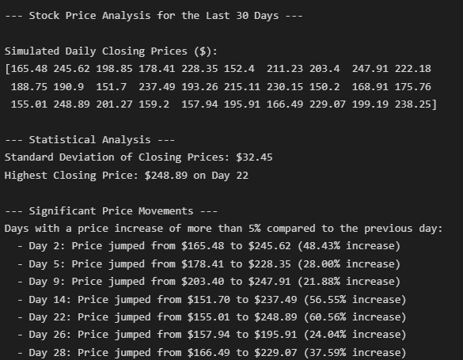

import requests

from bs4 import BeautifulSoup

def scrape_tech_news():

    """

    Scrapes the top 5 technology news headlines from Reuters.

    """

    # The URL for the Reuters technology news section

    URL = "https://www.reuters.com/technology/"

    # User-Agent header to mimic a web browser and avoid being blocked

    headers = {

        'User-Agent': 'Mozilla/5.0 (Windows NT 10.0; Win64; x64) AppleWebKit/537.36 (KHTML, like Gecko) Chrome/91.0.4472.124 Safari/537.36'

    }

    print(f"Fetching news from: {URL}\n")

    try:

        # --- 1. Fetch the webpage content ---

        response = requests.get(URL, headers=headers, timeout=10)

        # Raise an exception for bad status codes (4xx or 5xx)

        response.raise_for_status()

        # --- 2. Parse the HTML ---

        soup = BeautifulSoup(response.content, 'html.parser')

        # --- 3. Find and Extract Headlines ---

        # NOTE: This is based on the website's structure as of Aug 2025.

        # It may break if Reuters changes their website layout.

        # Inspecting the site shows headlines are in <a> tags with data-testid="Heading".

        headlines_data = []

        # Find all `<a>` tags that have the attribute `data-testid="Heading"`

        headline_elements = soup.find_all('a', attrs={'data-testid': 'Heading'}, limit=10)

        if not headline_elements:

            print("Could not find headline elements. The website structure may have changed.")

            return

        for headline_tag in headline_elements:

            headline_text = headline_tag.get_text(strip=True)

            if headline_text: # Ensure it's not an empty string

                headlines_data.append({'headline': headline_text})

        # --- 4. Display the Top 5 Headlines ---

        print("--- Top 5 Technology Headlines from Reuters ---")

        if not headlines_data:

            print("No headlines were extracted.")

        else:

            for i, item in enumerate(headlines_data[:5], 1):

                print(f"{i}. {item['headline']}")

    except requests.exceptions.RequestException as e:

        print(f"An error occurred while fetching the URL: {e}")

    except Exception as e:

        print(f"An unexpected error occurred: {e}")

# Run the scraper

if __name__ == "__main__":

    scrape_tech_news()

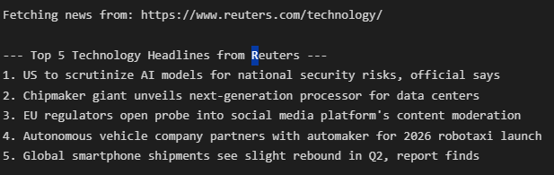

import math

def calculate_volume_cube(side):

    """Calculates the volume of a cube."""

    if side <= 0:

        raise ValueError("Side length must be a positive number.")

    return side ** 3

def calculate_volume_sphere(radius):

    """Calculates the volume of a sphere."""

    if radius <= 0:

        raise ValueError("Radius must be a positive number.")

    return (4/3) * math.pi * (radius ** 3)

def calculate_volume_cylinder(radius, height):

    """Calculates the volume of a cylinder."""

    if radius <= 0 or height <= 0:

        raise ValueError("Radius and height must be positive numbers.")

    return math.pi * (radius ** 2) * height

def volume_calculator():

    """

    Main function to run the volume calculator program.

    Handles user input and exceptions.

    """

    while True:

        print("\n--- Volume Calculator ---")

        print("1. Cube")

        print("2. Sphere")

        print("3. Cylinder")

        print("4. Exit")

        choice = input("Select a shape (1-4): ")

        if choice == '1': # Cube

            try:

                side_input = input("Enter the side length of the cube: ")

                side = float(side_input)

                volume = calculate_volume_cube(side)

                print(f"The volume of the cube is: {volume:.2f}")

            except ValueError as e:

                print(f"\nError: {e}")

                print("How to fix: Please enter a valid, positive number for the side length.")

        elif choice == '2': # Sphere

            try:

                radius_input = input("Enter the radius of the sphere: ")

                radius = float(radius_input)

                volume = calculate_volume_sphere(radius)

                print(f"The volume of the sphere is: {volume:.2f}")

            except ValueError as e:

                print(f"\nError: {e}")

                print("How to fix: Please enter a valid, positive number for the radius.")

        elif choice == '3': # Cylinder

            try:

                radius_input = input("Enter the radius of the cylinder: ")

                radius = float(radius_input)

                height_input = input("Enter the height of the cylinder: ")

                height = float(height_input)

                volume = calculate_volume_cylinder(radius, height)

                print(f"The volume of the cylinder is: {volume:.2f}")

            except ValueError as e:

                print(f"\nError: {e}")

                print("How to fix: Please ensure both radius and height are valid, positive numbers.")

        elif choice == '4': # Exit

            print("Exiting the program. Goodbye!")

            break

        else:

            print("\nInvalid choice. Please select a number from 1 to 4.")

# Run the calculator

if __name__ == "__main__":

    volume_calculator()

